Project Planning Phase
Project Planning Template (Product Backlog, Sprint Planning, Stories, Story points)

Date | 28 September 2026
Team ID | SWTID-2026-6339
Project Name | AI BlogNest
Maximum Marks | 5 Marks

Product Backlog, Sprint Schedule, and Estimation (4 Marks)
Use the below template to create product backlog and sprint schedule
Sprint | Functional Requirement (Epic) | User Story Number | User Story / Task | Story Points | Priority | Team Members
Sprint-1 | Project Setup & Authentication | USN-1 | As a user, I can register with my name, email and password (min 6 characters). | 3 | High
Sprint-1 |  | USN-2 | As a user, my password is hashed and duplicate emails are rejected. | 2 | High
Sprint-1 |  | USN-3 | As a user, I can log in and receive a JWT token (valid 7 days). | 3 | High
Sprint-1 |  | USN-4 | As a user, I can view my profile using my token. | 2 | Medium
Sprint-1 |  | USN-5 | As a developer, protected routes verify the JWT (auth middleware). | 3 | High
Sprint-1 |  | USN-6 | As a developer, I set up Express, MongoDB connection and the central error handler. | 4 | High
Sprint-1 |  | USN-7 | As a developer, request bodies are validated with express-validator. | 2 | High
Sprint-1 |  | USN-8 | As a developer, a health-check route confirms the API is running. | 1 | Low
Sprint-2 | Blog Management | USN-9 | As a user, I can create a blog with title, content and category. | 3 | High
Sprint-2 |  | USN-10 | As a reader, I can view all blogs, latest first. | 2 | High
Sprint-2 |  | USN-11 | As a reader, I can open a single blog by ID. | 2 | High
Sprint-2 |  | USN-12 | As a user, I can update my own blog. | 3 | High
Sprint-2 |  | USN-13 | As a user, I can delete my own blog. | 2 | High
Sprint-2 | Comments | USN-14 | As a user, I can add a comment to a blog. | 3 | High
Sprint-2 |  | USN-15 | As a reader, I can view all comments of a blog. | 2 | Medium
Sprint-2 |  | USN-16 | As a user, I can edit my own comment. | 2 | Medium
Sprint-2 |  | USN-17 | As a user, I can delete my own comment. | 1 | Medium
Sprint-3 | AI Content Tools | USN-18 | As a user, I can generate a blog from a topic using Gemini and save it. | 5 | High
Sprint-3 |  | USN-19 | As a user, the category is detected from the topic when I do not provide one. | 2 | Medium
Sprint-3 |  | USN-20 | As a user, AI output is cleaned of markdown symbols. | 2 | Medium
Sprint-3 |  | USN-21 | As a user, I can get a short summary of any blog content. | 3 | High
Sprint-3 |  | USN-22 | As a developer, the Gemini service handles API key, model selection and errors. | 3 | High
Sprint-3 | AI Chatbot | USN-23 | As a user, I can send a message to the chatbot and get a reply using the last 20 messages as context. | 5 | High
Sprint-4 | AI Chatbot | USN-24 | As a user, I can view my saved chat history. | 2 | Medium
Sprint-4 |  | USN-25 | As a user, I can clear my chat history. | 1 | Medium
Sprint-4 |  | USN-26 | As a user, my conversation is stored per user in MongoDB. | 3 | High
Sprint-4 | Testing & Documentation | USN-27 | As a tester, I have a Thunder Client / Postman collection for all endpoints. | 3 | Medium
Sprint-4 |  | USN-28 | As a developer, the README documents setup and endpoints. | 2 | Low
Sprint-4 |  | USN-29 | As a team, we run UAT and fix reported bugs. | 5 | High
Sprint-4 |  | USN-30 | As a team, we prepare environment configuration for deployment. | 4 | Medium

Project Tracker, Velocity & Burndown Chart: (4 Marks)
Sprint | Total Story Points | Duration | Sprint Start Date | Sprint End Date (Planned) | Story Points Completed (as on Planned End Date) | Sprint Release Date (Actual)
Sprint-1 | 20 | 6 Days | 07 Sep 2026 | 12 Sep 2026
Sprint-2 | 20 | 6 Days | 14 Sep 2026 | 19 Sep 2026
Sprint-3 | 20 | 6 Days | 21 Sep 2026 | 26 Sep 2026
Sprint-4 | 20 | 6 Days | 28 Sep 2026 | 03 Oct 2026

Velocity:
The team plans 4 sprints of 6 days each with a velocity of 20 story points per sprint (80 points in total). Average velocity (AV) per day = velocity / sprint duration = 20 / 6 = 3.33 story points per day.
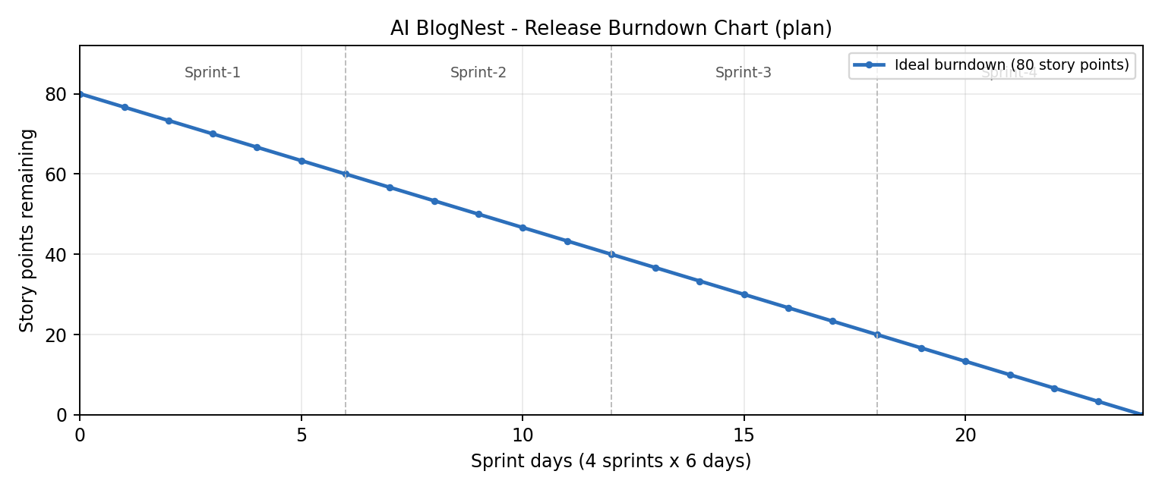

Burndown Chart:
A burn down chart shows the work left to do against time. The chart above is the ideal plan for AI BlogNest: 80 story points falling to zero over 24 working days. Record the actual points completed at the end of each sprint in the tracker above and plot them against this line.

https://www.visual-paradigm.com/scrum/scrum-burndown-chart/
https://www.atlassian.com/agile/tutorials/burndown-charts

Reference:
https://www.atlassian.com/agile/project-management
https://www.atlassian.com/agile/tutorials/how-to-do-scrum-with-jira-software
https://www.atlassian.com/agile/tutorials/epics
https://www.atlassian.com/agile/tutorials/sprints
https://www.atlassian.com/agile/project-management/estimation
https://www.atlassian.com/agile/tutorials/burndown-charts

